 

CLOUD BASED SMART FASHION RECOMMENDER APPLICATION

**A PROJECT REPORT**

***Submitted by***

**PONVARSHINI A** **MOHAMMED SHIYAS S** **MOHAMED ASIM VA** **NAVIN JAGADISH P**

***in partial fulfillment of the requirements for the award of the degreeof***

**BACHELOR OF ENGINEERING**

**IN**

**COMPUTER SCIENCE AND ENGINEERING**

**SRI KRISHNA COLLEGE OF ENGINEERING AND TECHNOLOGY**

**(An Autonomous Institution, Affiliated to Anna University Chennai - 600 025)**

**MAY & 2022**



**BONAFIDE CERTIFICATE**

Certified that this project report **“CLOUD BASED SMART FASHION RECOMMENDER APPLICATION”** is the bonafide work of **PONVARSHINI A (19EUCS105) , MOHAMMED SHIYAS S (19EUCS089) , MOHAMED ASIM VA (19EUCS087) , NAVIN**

**JAGADISH P (19EUCS100)** who carried out the project work under my supervision.

SIGNATURE SIGNATURE

**Dr.K. SASI KALA RANI, M.E., Ph.D., MAJIDHA FATHIMA KM , M.E HEAD OF THE DEPARTMENT SUPERVISOR**

Department of Computer Science and Engineering ,

Sri Krishna College of engineering and Technology Kuniyamuthur ,

Coimbatore

This project report is submitted for the Autonomous Project viva-voce examination held on

**INTERNAL EXAMINER EXTERNAL EXAMINER**

**ACKNOWLEDGEMENT**

We express our sincere thanks to the management and **Dr.J.JANET, M.E.,Ph.D.,** Principal, Sri Krishna College of Engineering and Technology, Coimbatore for providing us the facilities to carry out this project work.

We are highly indebt to **Dr.K. SASIKALA RANI, M.E.,Ph.D.,** Head of Computer Science and Engineering for her continuous evaluation, valuable suggestions and comments given during the course of the project work.

We are thankful to **Dr. Mohan Kumar P, M.E.,Ph.D.,** Project Co-ordinator**,** Department of Computer Science and Engineering for his continuous evaluation, valuable suggestions and comments given during the course of the project work.

We express our deep sense of gratitude to our guide**, MAJIDHA FATHIMA KM, M.E.,** Professor in the department of Computer science and Engineering for her valuable advice, guidance and support during the course of our project work.

By this, we express our heartfelt sense of gratitude and thanks to our beloved parents, family and friends who have all helped in collecting the resources and materials needed for this project and for their support during the study and implementation this project.

**TABLE OF CONTENTS**

|  |  |  |
| --- | --- | --- |
| **CHAPTER NO** | **TITLE ABSTRACT** | **PAGE NO** |
| **1** | **INTRODUCTION** |  |
|  | 1.1 Project Overview | **4** |
|  | 1.2 Purpose | **4** |
| **2** | **LITERATURE SURVEY** |  |
|  | 2.1 Existing problems | **5** |
|  | 2.2 References | **5** |
|  | 2.3 Problem Statement Definition | **6** |
| **3** | **IDEATION & PROPOSED SOLUTION** |  |
|  | 3.1 Empathy Map Canvas | **7** |
|  | 3.2 Ideation & Brainstorming | **8** |
|  | 3.3 Proposed Solution | **10** |
|  | 3.4 Problem Solution fit | **11** |
| **4** | **REQUIREMENT ANALYSIS** |  |
|  | 4.1 Functional requirements | **12** |
|  | 4.2 Non-Functional requirements | **12** |
| **5** | **PROJECT DESIGN** |  |
|  | 5.1 Data Flow Diagrams | **13** |
|  | 5.2 Solution & Technical Architecture | **14** |
|  | 5.3 User Stories | **15** |
| **6** | **PROJECT PLANNING & SCHEDULING** |  |
|  | 6.1 Sprint Planning & Estimation | **16** |
|  | 6.2 Sprint Delivery Schedule | **17** |

# CODING & SOLUTIONING

* + 1. Feature 1 : Login **18**
    2. Feature 2 : Signup **19**
    3. Feature 3 : Home **20**
    4. Feature 4 : Work **34**
    5. Feature 5 : Chatbot **34**
    6. Feature 6 : Add to cart **34**
    7. Feature 7 : Contact us **35**

7.2 Feature : Database Schema **36**

1. TESTING
   1. Test Cases **37**
   2. Test Strategy and Approach **37**
   3. Integration Testing **37**
   4. Acceptance Testing **38**
   5. Unit Testing **38**
2. RESULTS
   1. Performance Metrics **39**
   2. Screenshots **39**
3. ADVANTAGES & DISADVANTAGES 44
4. CONCLUSION 45
5. FUTURE SCOPE 46
6. APPENDIX 47

**CHAPTER 1 INTRODUCTION**

# PROJECT OVERVIEW

A smart fashion recommendation system is a system that is programmed to predict future preferable items from a large set of collections. A recommendation system works either by using user preferences or by using the items most preferred by all users. The main challenge in building a fashion recommendation system is that it is a very dynamic industry. It changes very often when it comes to seasons, festivals, pandemic conditions like coronavirus and many more.Smart fashion recommendations shouldn’t be based solely on personal taste and past activity of the customer.

There are many external factors (many of which are emotional) that make creating a fashion recommendation system all the more complex. Public perceptions must be taken into account, as well as fashion rules, dress rules and current trends. Image-based fashion recommendation systems (FRSs) have attracted a huge amount of attention from fast fashion retailers as they provide a personalized shopping experience to consumers.

# PURPOSE

In recent years, the textile and fashion industries have witnessed an enormous amount of growth in fast fashion. The main challenge in building a fashion recommendation system is that it is a very dynamic industry. It changes very often when it comes to seasons, festivals, pandemic conditions like coronavirus and many more.Smart fashion recommendations shouldn’t be based solely on personal taste and past activity of the customer. There are many external factors (many of which are emotional) that make creating a fashion recommendation system all the more complex. Public perceptions must be taken into account, as well as fashion rules, dress rules and current trends.On e-commerce platforms, where numerous choices are available, an efficient recommendation system is required to sort, order, and efficiently convey relevant product content or information to users.

# CHAPTER 2 LITERATURE SURVEY

* 1. **EXISTING PROBLEM**

Smart Recommendation system is referred to as a decision-making approach for users under a multidimensional information environment . It has also been defined as an e-commerce tool, which helps consumers search based on knowledge that is related to a consumer’s choices and preferences . Other websites related to smart fashion recommender system , if we want to search for a particular trend it consumes much time to get the accurate result . In various smart fashion recommender websites , if a customer has a doubt and in need of customer service , it will take plenty of time to get a reply from customer service.

# REFERENCES

* + 1. Mr. Samit Chakraborty and Mr. Saiful Hoque, Fashion Recommendation Systems, Models Anf Methods (2021)
    2. Mr. Malcolm Bernard, Fashion As Communication (2008)
    3. Ms. Jia Jia and Mr. Ke Gao, Trip Outfits Advisor: Location Oriented Clothing Recommendation (2016)
    4. Mr. T. H. Ying Huang, Outfit Recommendation Based On Deep Learning (2017)
    5. Mr. Gregory F. Cooper and Mr. Edward Hershkovits, ABayesian Method For The Induction Of Probabilistic Networks From Data” (1992)
    6. Mr. Wei Zhang and Mr. Bo Begole, Real Time Clothes Comparison Based On Multiviewvision(2008)
    7. Mrs. Qingqing Mao and Mr. Aihua Dong, Intelligent Costume Recommendation System Based on Expert System(2018)

# PROBLEM STATEMENT

However, now there are plenty of methods to obtain information about the consumer’s liking for a product through the Internet. These data can be retrieved in the forms of voting, tagging, reviewing and the number of likes or dislikes the user provides. It may also include reviews written in blogs, videos uploaded on YouTube or messages about a product. Regardless of communication and presentation, medium preferences are expressed in the form of numerical values . Nowadays , customer have difficulty to search many websites to find fashion clothes and accessories . It is a web application that particularly provides the type of product you are looking for . The goal of this project is that the customer can directly make online shopping based on their choice without any search. By interacting with chatbot , this web application provides satisfaction among customers regarding products .

# CHAPTER 3

**IDEATION AND PROPOSED SOLUTION**

# EMPATHY MAP CANVAS

An empathy map is a simple, easy-to-digest visual that captures knowledge about a user's behaviours and attitudes. It is a useful tool to helps teams better understand their users.

Creating an effective solution requires understanding the true problem and the person who is experiencing it. The exercise of creating the map helps participants consider things from the user's perspective along with his or her goals and challenges.

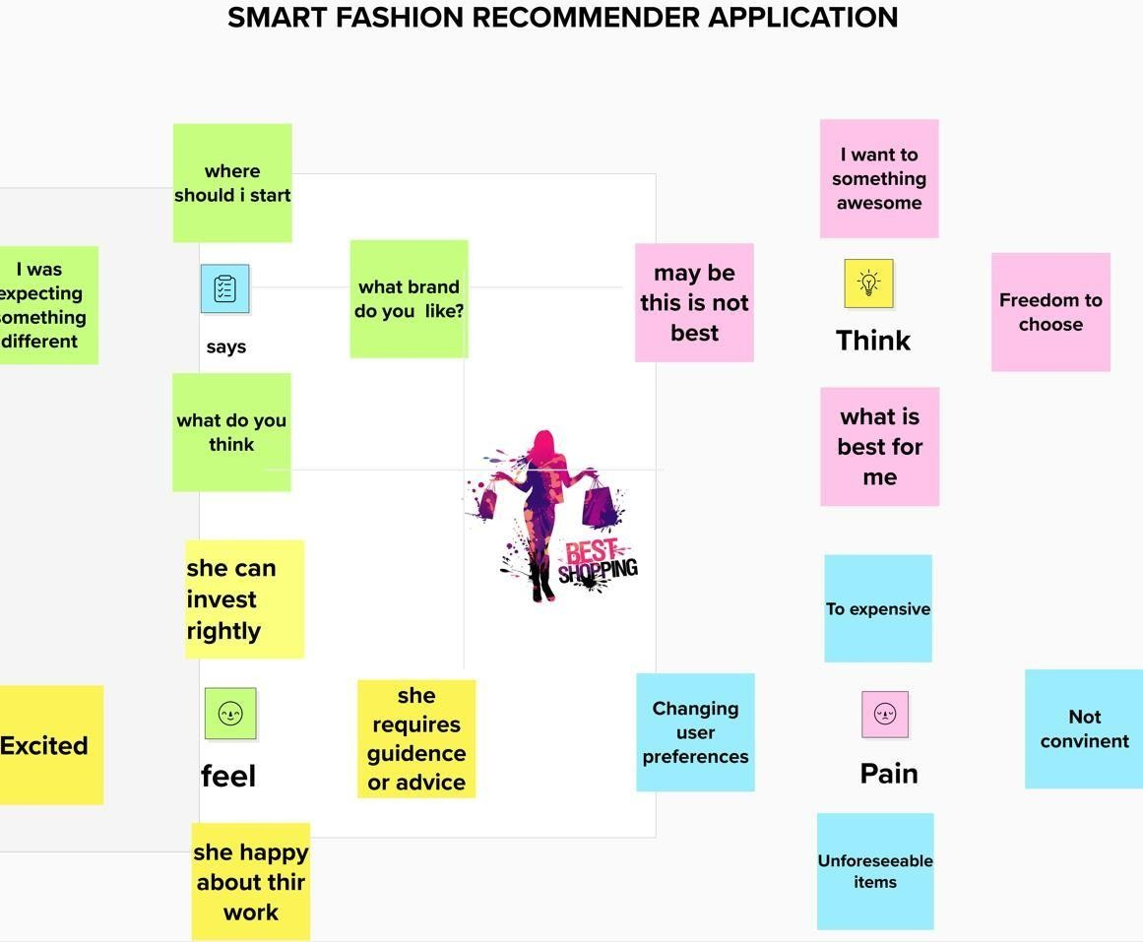

# IDEATION AND BRAINSTORMING

* + 1. **BRAIN STORMING**

Brainstorming provides a free and open environment that encourages everyone within a team to participate in the creative thinking process that leads to problem solving. Prioritizing volume over value, out-of-the-box ideas are welcome and built upon, and all participants are encouraged to collaborate, helping each other develop a rich amount of creative solutions.

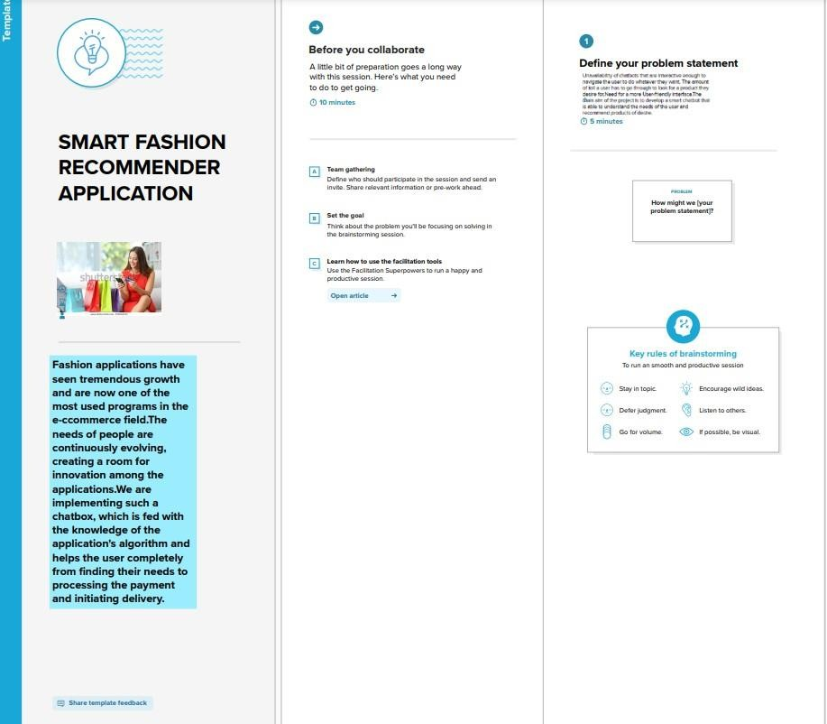

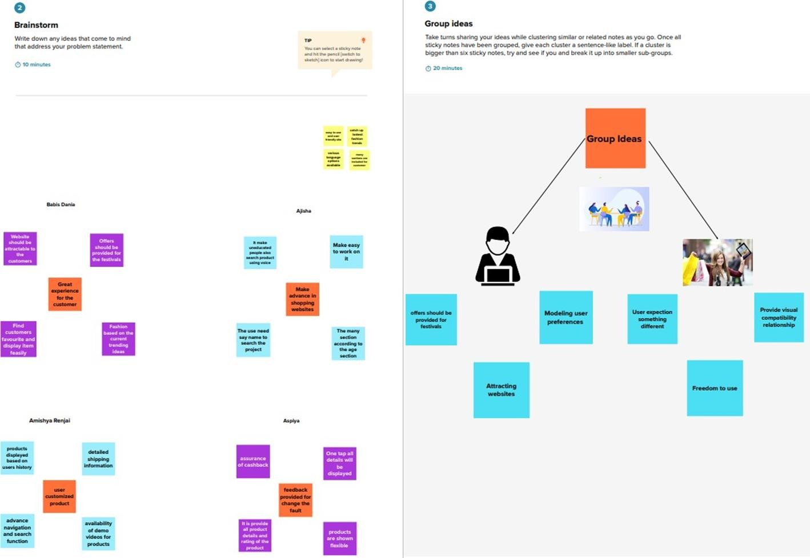

* + 1. **IDEA PRIORITIZATION**

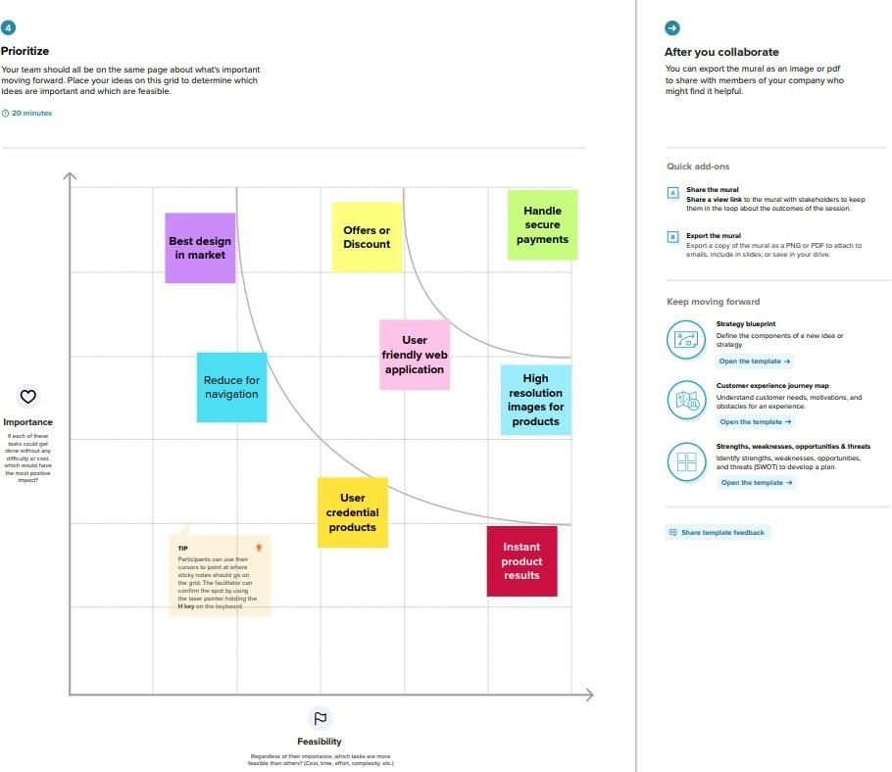

# PROPOSED SOLUTION

It provides a simple path for the customers to choose the type of product required regarding the customer’s wish . There will be no difficulty for customers in searching the products because the style and fashion of products are readily available where you can choose according to the need of customer . By using artificial customer service like chatbot , provides quick clarification for customer’s doubt . Also , it consumes less time for the customers to do their shopping

|  |  |  |
| --- | --- | --- |
| S.NO | **Parameter** | **Description** |
| 1 | Problem statement | Customer feel difficult when search many websites to find fashion clothes and accessories. |
| 2 | Idea/solution description | Customer directly make online shopping based on customer choice without any search. |
| 3 | Novelty/Uniqueness | The customer will talk to chat bot regarding the products. |
| 4 | Social impact/customer satisfaction | The user friendly, interface form chat bot finding dress makes customer satisfied. |
| 5 | Business model | The chat bot sells our products to customer. |
| 6 | Scalability of the solution | We can easily scalable our application by increases the items and products. |

# PROBLEM SOLUTION FIT

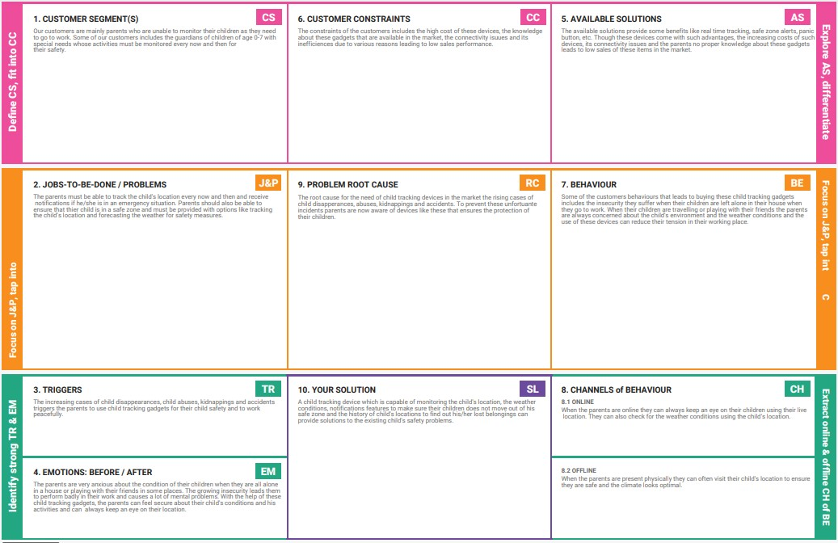

**CHAPTER-4 REQUIREMENT ANALYSIS**

# FUNCTIONAL REQUIREMENTS

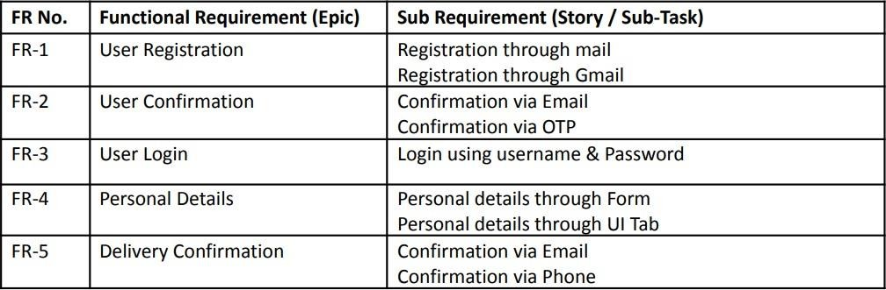

* 1. **NON-FUNCTIONAL REQUIREMENTS**

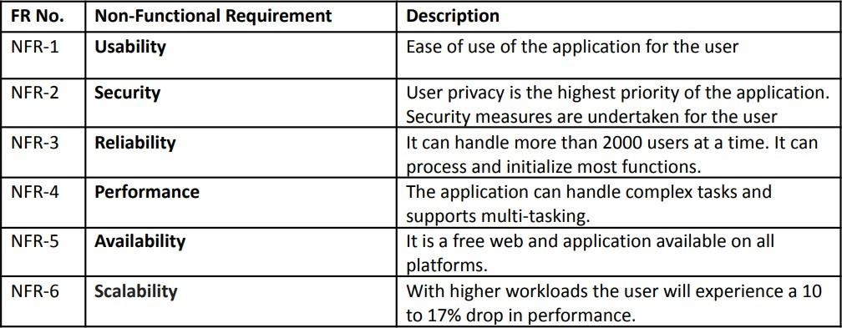

# CHAPTER 5 PROJECT DESIGN

* 1. **DATA FLOW DIAGRAM**

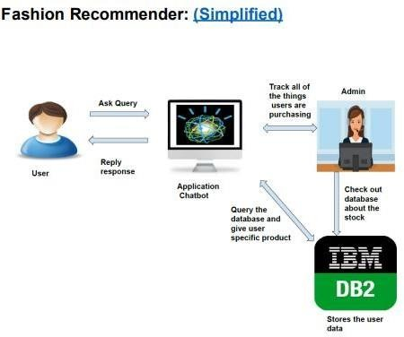

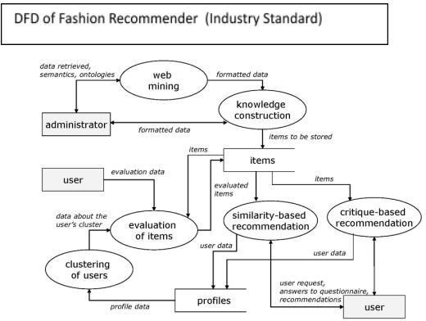

# SOLUTION AND TECHNICAL ARCHITECTURE

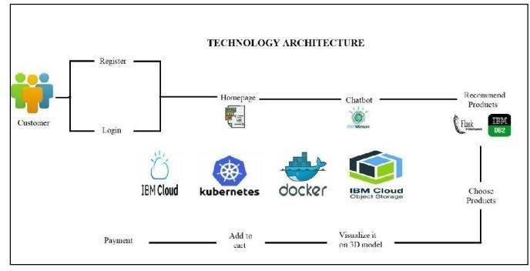

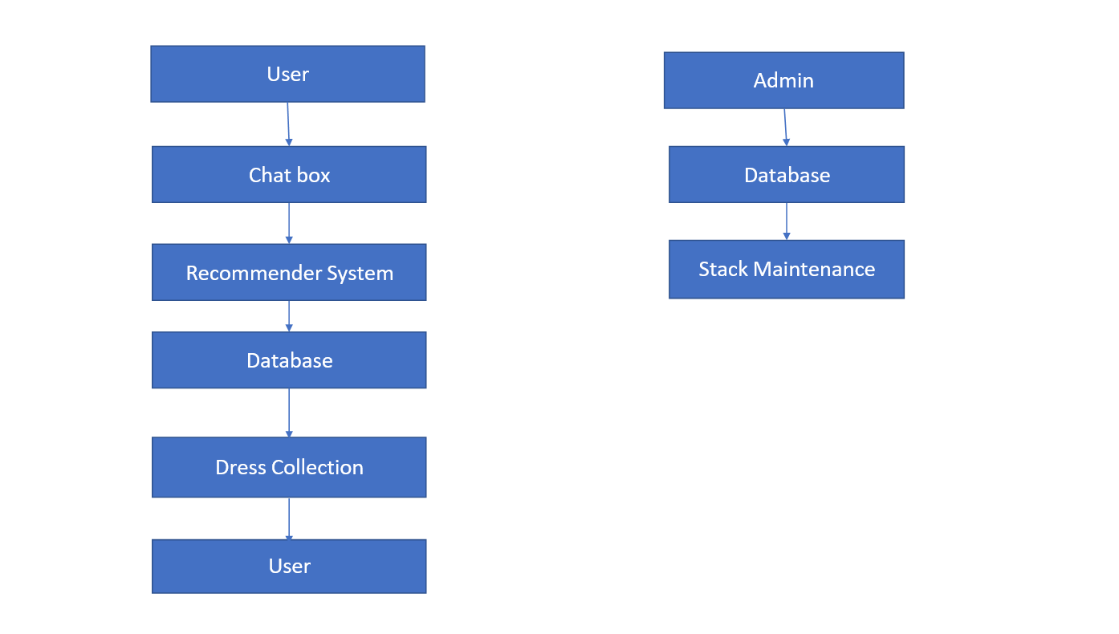

* 1. **USER STORIES**

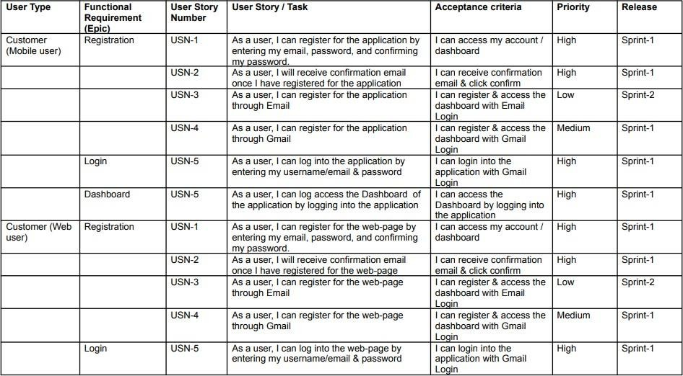

# CHAPTER 6

**PROJECT PLANNING AND SCHEDULING**

# SPRINT PLANNING AND ESTIMATION

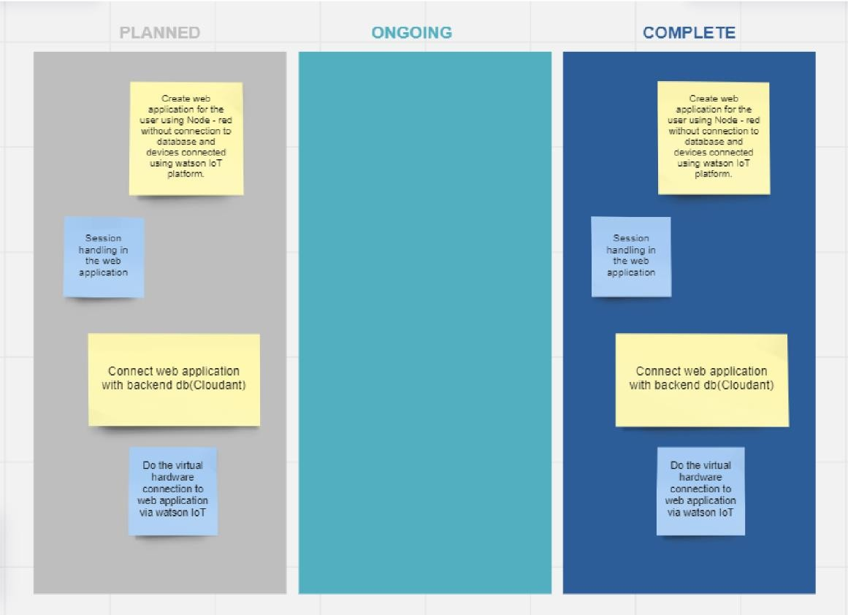

* 1. **SPRINT DELIVERY SCHEDULE**

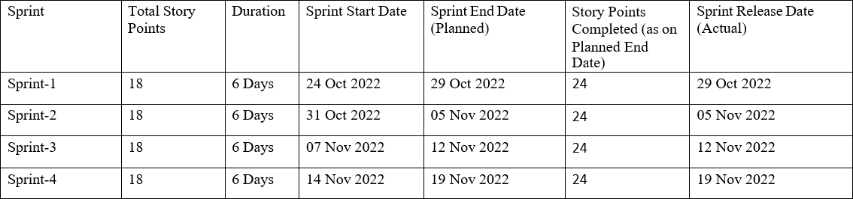

# CHAPTER 7 CODING & SOLUTIONING

# FEATURE 1 : LOGIN

# Algorithm :

* + - 1. Enter the credentials and hit enter (email and password).
      2. If already logged in user is taken to home page
      3. Else , check for validity of credentials entered using query to cloudant db.
      4. On correct credentials , user is taken to home page.

# Login.html:

<!DOCTYPE html>

<html lang="en">

<head>

<title>Login</title>

<link rel="icon" type="image/x-icon" href="images/download.jpg">

<link rel="stylesheet" href="style.css" />

<link href="[https://fonts.googleapis.com/css2?family=Roboto:wght@300&display=swap](https://fonts.googleapis.com/css2?family=Roboto%3Awght%40300&display=swap)" rel="stylesheet"

/>

</head>

<body>

<div class="login-box" style="margin-top:175px ;">

<h1>Login</h1>

<form action="action_page.html">

<label>Email</label>

<input type="email" placeholder="" />

<label>Password</label>

<input type="password" placeholder="" />

<input type="submit" value="Submit" />

</form>

</div>

<p class="para-2">

Not have an account? <a href="signup.html">Sign Up Here</a>

</p>

</body>

</html>

# FEATURE 2 : SIGNUP Algorithm :

* + - 1. Enter the signup form fields (first name , last name email , password )and hit enter.
      2. All credentials are validated at client side.
      3. Email is checked if already registered or not in the database.
      4. If already registered , notification displayed. Or else, the user is taken to the successful signup page.

# Signup.html :

<!DOCTYPE html>

<html lang="en">

<head>

<title>Sign Up</title>

<link rel="icon" type="image/x-icon" href="images/download.jpg">

<link rel="stylesheet" href="style.css" />

<link href="[https://fonts.googleapis.com/css2?family=Roboto:wght@300&display=swap](https://fonts.googleapis.com/css2?family=Roboto%3Awght%40300&display=swap)" rel="stylesheet"

/>

</head>

<body>

<div class="signup-box">

<h1>Sign Up</h1>

<form action="action_page.html">

<label>First Name</label>

<input type="text" placeholder="" />

<label>Last Name</label>

<input type="text" placeholder="" />

<label>Email</label>

<input type="email" placeholder="" />

<label>Password</label>

<input type="password" placeholder="" />

<label>Confirm Password</label>

<input type="password" placeholder="" />

<input type="submit" value="Submit" />

</form>

<p>

By clicking the Sign Up button,you agree to our <br />

<a href="terms.html">Terms and Condition</a> and <a href="privacy.html">Policy Privacy</a>

</p>

</div>

<p class="para-2">

Already have an account? <a href="login.html">Login here</a>

</p>

</body>

</html>

# FEATURE 3 : HOME Algorithm :

* + - 1. If the user is logged out , he/she is taken to the login page.
      2. Home page buttons are displayed (Team , Work , Contact, Logout)
      3. If buttons are clicked , the user is taken to the requested page.

# Home.html:

<!DOCTYPE html>

<html>

<title>Trendy Fashion</title>

<link rel="icon" type="image/x-icon" href="images/download.jpg">

<meta charset="UTF-8">

<meta name="viewport" content="width=device-width, initial-scale=1">

<link rel="stylesheet" href="https://[www.w3schools.com/w3css/4/w3.css](http://www.w3schools.com/w3css/4/w3.css)">

<link rel="stylesheet" href="https://fonts.googleapis.com/css?family=Raleway">

<link rel="stylesheet" href="https://cdnjs.cloudflare.com/ajax/libs/font- awesome/4.7.0/css/font-awesome.min.css">

<link rel="stylesheet" href="[https://cdn.jsdelivr.net/npm/bootstrap@4.6.2/dist/css/bootstrap.min.css](https://cdn.jsdelivr.net/npm/bootstrap%404.6.2/dist/css/bootstrap.min.css)" integrity="sha384- xOolHFLEh07PJGoPkLv1IbcEPTNtaed2xpHsD9ESMhqIYd0nLMwNLD69Npy4HI+N" crossorigin="anonymous">

<style> body, h1,

h2,

h3,

h4,

h5,

h6 {

font-family: "Raleway", sans-serif

}

body, html {

height: 100%;

line-height: 1.8;

}

/* Full height image header */

.bgimg-1 {

background-position: center;

background-size: cover;

background-image: url("images/clothing-line.jpg"); min-height: 100%;

}

.w3-bar .w3-button { padding: 16px;

}

</style>

<body>

<!-- Navbar (sit on top) -->

<div class="w3-top">

<div class="w3-bar w3-white w3-card" id="myNavbar">

<a href="#home" class="w3-bar-item w3-button w3-wide">LOGO</a>

<!-- Right-sided navbar links -->

<div class="w3-right w3-hide-small">

<a href="#about" class="w3-bar-item w3-button">ABOUT</a>

<a href="#team" class="w3-bar-item w3-button"><i class="fa fa-user"></i> TEAM</a>

<a href="#work" class="w3-bar-item w3-button"><i class="fa fa-th"></i> WORK</a>

<a href="#contact" class="w3-bar-item w3-button"><i class="fa fa-envelope"></i> CONTACT</a>

<a href="login.html" class="w3-bar-item w3-button"><i class="fa fa-sign-out" aria- hidden="true"></i> LOGOUT</a>

</div>

<!-- Hide right-floated links on small screens and replace them with a menu icon -->

<a href="javascript:void(0)" class="w3-bar-item w3-button w3-right w3-hide-large w3- hide-medium"

onclick="w3_open()">

<i class="fa fa-bars"></i>

</a>

</div>

</div>

<!-- Sidebar on small screens when clicking the menu icon -->

<nav class="w3-sidebar w3-bar-block w3-black w3-card w3-animate-left w3-hide-medium w3-hide-large"

style="display:none" id="mySidebar">

<a href="javascript:void(0)" onclick="w3_close()" class="w3 -bar-item w3-button w3-large w3-padding-16">Close ×</a>

<a href="#about" onclick="w3_close()" class="w3-bar-item w3-button">ABOUT</a>

<a href="#team" onclick="w3_close()" class="w3-bar-item w3-button">TEAM</a>

<a href="#work" onclick="w3_close()" class="w3-bar-item w3-button">WORK</a>

<a href="#contact" onclick="w3_close()" class="w3-bar-item w3-button">CONTACT</a>

</nav>

<!-- Header with full-height image -->

<header class="bgimg-1 w3-display-container w3-grayscale-min" id="home">

<div class="w3-display-left w3-text-white" style="padding:48px">

<span class="w3-jumbo w3-hide-small">Start something that matters</span><br>

<span class="w3-xxlarge w3-hide-large w3-hide-medium">Start something that matters</span><br>

<span class="w3-large">Stop wasting valuable time with projects that just isn't you.</span>

<p><a href="#about"

class="w3-button w3-white w3-padding-large w3-large w3-margin-top w3-opacity w3- hover-opacity-off">Learn more

and start today</a></p>

</div>

<div class="w3-display-bottomleft w3-text-grey w3-large" style="padding:24px 48px">

<i class="fa fa-facebook-official w3-hover-opacity"></i>

<i class="fa fa-instagram w3-hover-opacity"></i>

<i class="fa fa-snapchat w3-hover-opacity"></i>

<i class="fa fa-pinterest-p w3-hover-opacity"></i>

<i class="fa fa-twitter w3-hover-opacity"></i>

<i class="fa fa-linkedin w3-hover-opacity"></i>

</div>

</header>

<!-- About Section -->

<div class="w3-container" style="padding:128px 16px" id="about">

<h3 class="w3-center">ABOUT THE COMPANY</h3>

<p class="w3-center w3-large">Key features of our company</p>

<div class="w3-row-padding w3-center" style="margin-top:64px">

<div class="w3-quarter">

<i class="fa fa-desktop w3-margin-bottom w3-jumbo w3-center"></i>

<p class="w3-large">Responsive</p>

<p>“When we ground ourselves in the present moment, we spontaneously connect better with others.”</p>

</div>

<div class="w3-quarter">

<i class="fa fa-heart w3-margin-bottom w3-jumbo"></i>

<p class="w3-large">Passion</p>

<p>"Believe in your heart that you're meant to live a life full of passion, purpose, magic and miracles.”</p>

</div>

<div class="w3-quarter">

<i class="fa fa-diamond w3-margin-bottom w3-jumbo"></i>

<p class="w3-large">Design</p>

<p>"Design creates culture. Culture shapes values. Values determine the future."</p>

</div>

<div class="w3-quarter">

<i class="fa fa-cog w3-margin-bottom w3-jumbo"></i>

<p class="w3-large">Support</p>

<p>“There’s a fine line between support and stalking and let’s all stay on the right side of that.”</p>

</div>

</div>

</div>

<!-- Promo Section - "We know design" -->

<div class="w3-container w3-light-grey" style="padding:128px 16px">

<div class="w3-row-padding">

<div class="w3-col m6">

<h3>We know design.</h3>

<p>"Make it simple, but significant."</p>

<p><a href="#work" class="w3-button w3-black"><i class="fa fa-th"> </i> View Our Works</a></p>

</div>

<div class="w3-col m6">

<img class="w3-image w3-round-large" src="images/clothing.jpg" alt="Buildings" width="700" height="394">

</div>

</div>

</div>

<!-- Team Section -->

<div class="w3-container" style="padding:128px 16px" id="team">

<h3 class="w3-center">THE TEAM</h3>

<p class="w3-center w3-large">The ones who runs this company</p>

<div class="w3-row-padding w3-grayscale" style="margin-top:64px">

<div class="w3-col l3 m6 w3-margin-bottom">

<div class="w3-card">

<img src="images/team2.jpg" alt="John" style="width:100%">

<div class="w3-container">

<h3>John Doe</h3>

<p class="w3-opacity">CEO & Founder</p>

<p>Manages and directs the company toward its primary goals and objectives.

Oversees employment decisions

at the executive level of the company. Leads a team of executives to consider major decisions including

acquisitions, mergers, joint ventures, or large-scale expansion.</p>

<p><button class="w3-button w3-light-grey w3-block"><i class="fa fa- envelope"></i> Contact</button></p>

</div>

</div>

</div>

<div class="w3-col l3 m6 w3-margin-bottom">

<div class="w3-card">

<img src="Images/team1.jpg" alt="Jane" style="width:100%">

<div class="w3-container">

<h3>Anja Doe</h3>

<p class="w3-opacity">Stylist</p>

<p>Responsible for the visual style and images in magazines, newspapers, product packaging.Inspire and guide

the vision

of the design team, oversee the work of illustrators, graphic/visualdesigners, photographers, and others

who are

engaged in artwork or layout design.</p>

<p><button class="w3-button w3-light-grey w3-block"><i class="fa fa- envelope"></i> Contact</button></p>

</div>

</div>

</div>

<div class="w3-col l3 m6 w3-margin-bottom">

<div class="w3-card">

<img src="images/team3.jpg" alt="Mike" style="width:100%">

<div class="w3-container">

<h3>Mike Ross</h3>

<p class="w3-opacity">Designer</p>

<p>Plan, create and code internet sites and web pages, many of which combine text

with sounds, pictures,

graphics

and video clips.Responsible for creating the design and layout of a website or web

pages.

It and can mean working on a brand new website or updating an already existing

site.</p>

<p><button class="w3-button w3-light-grey w3-block"><i class="fa fa- envelope"></i> Contact</button></p>

</div>

</div>

</div>

<div class="w3-col l3 m6 w3-margin-bottom">

<div class="w3-card">

<img src="images/team4.jpg" alt="Dan" style="width:100%">

<div class="w3-container">

<h3>Dan Star</h3>

<p class="w3-opacity">Marketing Manager</p>

<p>Conceptualize visuals based on requirements. Prepare rough drafts and present ideas. Develop

illustrations,

logos and other designs using software or by hand. Use the appropriate colors and layouts for each

graphic.

Work with copywriters and creative director to produce final design.</p>

<p><button class="w3-button w3-light-grey w3-block"><i class="fa fa- envelope"></i> Contact</button></p>

</div>

</div>

</div>

</div>

</div>

<!-- Promo Section "Statistics" -->

<div class="w3-container w3-row w3-center w3-dark-grey w3-padding-64">

<div class="w3-quarter">

<span class="w3-xxlarge">7+</span>

<br>Partners

</div>

<div class="w3-quarter">

<span class="w3-xxlarge">5K+</span>

<br>Designers

</div>

<div class="w3-quarter">

<span class="w3-xxlarge">10K+</span>

<br>Happy Clients

</div>

<div class="w3-quarter">

<span class="w3-xxlarge">150+</span>

<br>Awards

</div>

</div>

<!-- Work Section -->

<div class="w3-container" style="padding:128px 16px" id="work">

<h3 class="w3-center">OUR WORK</h3>

<p class="w3-center w3-large">What we've done for people</p>

<div style="margin-left: 40px;">

<a href="view/view1.html">

<img src="https://fashionimages.s3.us-south.cloud-object- storage.appdomain.cloud/fashion1.jpg"

alt="womenfashion" srcset=""></a>

<a href="view/view2.html">

<img src="https://fashionimages.s3.us-south.cloud-object- storage.appdomain.cloud/fashion2.jpg"

alt="womenfashion" srcset=""></a>

<a href="view/view3.html">

<img src="https://fashionimages.s3.us-south.cloud-object- storage.appdomain.cloud/c1.jpg"

alt="womenfashion"srcset=""></a>

<a href="view/view4.html">

<img src="https://fashionimages.s3.us-south.cloud-object- storage.appdomain.cloud/fashion4.jpg"

alt="womenfashion" srcset=""></a>

<a href="view/view5.html">

<img src="https://fashionimages.s3.us-south.cloud-object- storage.appdomain.cloud/f1.jpg"

alt="womenfashion" srcset=""></a>

<a href="view/view6.html">

<img src="https://fashionimages.s3.us-south.cloud-object- storage.appdomain.cloud/tr9.jpg"

alt="womenfashion"srcset=""></a>

<a href="view/view7.html">

<img src="https://fashionimages.s3.us-south.cloud-object- storage.appdomain.cloud/a1.jpg"

alt="womenfashion"srcset=""></a>

</div>

<div class="list-group"style="text-align:center" >

<a class="list-group-item list-group-item-action"><h1>Find yourself more in:</h1></a>

<a href="category/womenformals.html" class="list-group-item list-group-item-action list- group-item-primary"><h1>Women formals</h1></a>

<a href="category/menformals.html" class="list-group-item list-group-item-action list- group-item-secondary"><h1>Men formals</h1></a>

<a href="category/kidsfashion.html" class="list-group-item list-group-item-action list- group-item-success"><h1>Kids fashion</h1></a>

<a href="category/fashionsilks.html" class="list-group-item list-group-item-action list- group-item-danger"><h1>Fashion silks</h1></a>

<a href="category/chappels.html" class="list-group-item list-group-item-action list- group-item-warning"><h1>Chappels</h1></a>

<a href="category/bags.html" class="list-group-item list-group-item-action list-group- item-info"><h1>Bags</h1></a>

</div>

<script> window.watsonAssistantChatOptions = {

integrationID: "271c9517-d9d6-417b-a76c-1d8578385dee", // The ID of this integration. region: "us-south", // The region your integration is hosted in.

serviceInstanceID: "20470815-619a-40f1-8c14-816220ff2257", // The ID of your service instance.

onLoad: function (instance) { instance.render(); }

};

setTimeout(function () {

const t = document.createElement('script');

t.src = "https://web-chat.global.assistant.watson.appdomain.cloud/versions/" + (window.watsonAssistantChatOptions.clientVersion || 'latest') + "/WatsonAssistantChatEntry.js";

document.head.appendChild(t);

});

</script>

</div>

<!-- Modal for full size images on click-->

<div id="modal01" class="w3-modal w3-black" onclick="this.style.display='none'">

<span class="w3-button w3-xxlarge w3-black w3-padding-large w3-display-topright" title="Close Modal Image">×</span>

<div class="w3-modal-content w3-animate-zoom w3-center w3-transparent w3-padding- 64">

<img id="img01" class="w3-image">

<p id="caption" class="w3-opacity w3-large"></p>

</div>

</div>

<!-- Skills Section -->

<div class="w3-container w3-light-grey w3-padding-64">

<div class="w3-row-padding">

<div class="w3-col m6">

<h3>Our Skills.</h3>

<p>Sketching designs <br>

Selecting fabrics and embellishments and sourcing suppliers<br> Sewing and creating physical pieces<br>

Hosting model fittings and making necessary alterations<br> Participating in fashion shows<br>

Communicating with clients and the media<br> Marketing designs<br>

Promoting designs to creative directors and merchandisers<br>

</p>

</div>

<div class="w3-col m6">

<p class="w3-wide"><i class="fa fa-camera w3-margin-right"></i>Styling</p>

<div class="w3-grey">

<div class="w3-container w3-dark-grey w3-center" style="width:90%">90%</div>

</div>

<p class="w3-wide"><i class="fa fa-desktop w3-margin-right"></i>Designing</p>

<div class="w3-grey">

<div class="w3-container w3-dark-grey w3-center" style="width:85%">85%</div>

</div>

<p class="w3-wide"><i class="fa fa-photo w3-margin-right"></i>Marketing</p>

<div class="w3-grey">

<div class="w3-container w3-dark-grey w3-center" style="width:75%">80%</div>

</div>

</div>

</div>

</div>

<!-- Contact Section -->

<div class="w3-container w3-light-grey" style="padding:128px 16px" id="contact">

<h3 class="w3-center">CONTACT</h3>

<p class="w3-center w3-large">Lets get in touch. Send us a message:</p>

<div style="margin-top:48px">

<p><i class="fa fa-map-marker fa-fw w3-xxlarge w3-margin-right"></i>kaniyakumari, India.</p>

<p><i class="fa fa-phone fa-fw w3-xxlarge w3-margin-right"></i> Phone:

+919876543210</p>

<p><i class="fa fa-envelope fa-fw w3-xxlarge w3-margin-right"> </i> Email: [trendyfashion@gmail.com](mailto:trendyfashion@gmail.com)</p>

<br>

<form action="/action_page.php" target="_blank">

<p><input class="w3-input w3-border" type="text" placeholder="Name" required name="Name"></p>

<p><input class="w3-input w3-border" type="text" placeholder="Email" required name="Email"></p>

<p><input class="w3-input w3-border" type="text" placeholder="Subject" required name="Subject"></p>

<p><input class="w3-input w3-border" type="text" placeholder="Message" required name="Message"></p>

<p>

<button class="w3-button w3-black" type="submit" input type="reset">

<i class="fa fa-paper-plane"><a style="text-decoration: none;" href="submit.html"> SEND MESSAGE </a></i>

</button>

</p>

</form>

<!-- Image of location/map -->

<img src="images/map.jpg" class="w3-image w3-greyscale" style="width:100%;margin- top:48px">

</div>

</div>

<!-- Footer -->

<footer class="w3-center w3-black w3-padding-64">

<a href="#home" class="w3-button w3-light-grey"><i class="fa fa-arrow-up w3-margin- right"></i>To the top</a>

<div class="w3-xlarge w3-section">

<i class="fa fa-facebook-official w3-hover-opacity"></i>

<i class="fa fa-instagram w3-hover-opacity"></i>

<i class="fa fa-snapchat w3-hover-opacity"></i>

<i class="fa fa-pinterest-p w3-hover-opacity"></i>

<i class="fa fa-twitter w3-hover-opacity"></i>

<i class="fa fa-linkedin w3-hover-opacity"></i>

</div>

</footer>

<script>

// Modal Image Gallery function onClick(element) {

document.getElementById("img01").src = element.src; document.getElementById("modal01").style.display = "block"; var captionText = document.getElementById("caption"); captionText.innerHTML = element.alt;

}

// Toggle between showing and hiding the sidebar when clicking the menu icon var mySidebar = document.getElementById("mySidebar");

function w3_open() {

if (mySidebar.style.display === 'block') { mySidebar.style.display = 'none';

} else {

mySidebar.style.display = 'block';

}

}

// Close the sidebar with the close button function w3_close() { mySidebar.style.display = "none";

}

</script>

</body>

</html>

# FEATURE 4 : WORK Algorithm :

* + - 1. If the user is logged out , he/she is taken to the login page.
      2. If we click the button Work it has many features like Womens Formals , Mens Formals , Chappals , Bags , Kids fashion , Fashion Skills.
      3. On selecting a particular feature it shows plenty collections .

# FEATURE 5 : CHATBOT Algorithm :

* + - 1. If the user is logged out , he/she is taken to the login page.
      2. In this web application , if the user has to clarify some doubts chatbot is available. After receiving the message from customer it immediately sends a reply message.

# FEATURE 6 : ADDING TO CART Algorithm :

* + - 1. If the user is logged out , he/she is taken to the login page.
      2. If a product is selected it moves to cart and further process takes place.

# FEATURE 7: CONTACT US Code:

<!DOCTYPE html>

<html lang="en">

<head>

<title>Response</title>

<link rel="icon" type="image/x-icon" href="images/download.jpg">

<link rel="stylesheet" href="style.css" />

<link href="[https://fonts.googleapis.com/css2?family=Roboto:wght@300&display=swap](https://fonts.googleapis.com/css2?family=Roboto%3Awght%40300&display=swap)" rel="stylesheet"

/>

</head>

<body>

<div class="signup-box" style="height: 390px; margin-top:175px ;">

<h1>Response Submission Sucessfull</h1>

<p style="margin-left: 2em; margin-right: 2em;">Your response has been submitted sucessfully.

</p>

<a style="margin-left: 10em;" href="action_page.html">Back</a>

</div>

</body>

</html>

# 7.2 DATABASE SCHEMA

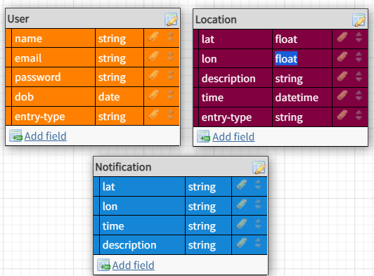

**CHAPTER 8 TESTING**

# TEST CASES

* + 1. Signup with already registered mail ID.
    2. Signup with wrong form data entered.
    3. Entering home page with logged out session.
    4. Clicking home page buttons with logged out session.
    5. Product added to cart page.
    6. Every feature in home page must work.

# TEST STRATEGY AND APPROACH

Field testing will be performed manually and functional tests will be written in detail.

# Test objectives

* All field entries must work properly.
* Pages must be activated from the identified link.
* The entry screen, messages and responses must not be delayed.

# Features to be tested

* Verify that the entries are of the correct format
* No duplicate entries should be allowed
* All links should take the user to the correct page.

# 8.3. Integration Testing

Software integration testing is the incremental integration testing of two or more integrated software components on a single platform to produce failures caused by interface defects. The task of the integration test is to check that components or software applications, e.g. components in a software system or – one step up – software applications at the company level – interact without error.

**Test Results:** All the test cases mentioned above passed successfully. No defects encountered.

# 8.4 Acceptance Testing

User Acceptance Testing is a critical phase of any project and requires significant participation by the end user. It also ensures that the system meets the functional requirements.

**Test Results:** All the test cases mentioned above passed successfully. No defects encountered.

**8.5. Unit testing**

Unit testing involves the design of test cases that validate that the internal program logic is functioning properly, and that program inputs produce valid outputs. All decision branches and internal code flow should be validated. It is the testing of individual software units of the application .it is done after the completion of an individual unit before integration. This is a structural testing, that relies on knowledge of its construction and is invasive. Unit tests perform basic tests at component level and test a specific business process, application, and/or system configuration.

# CHAPTER 9 RESULTS

# PERFORMANCE METRICS

* + 1. Planned value : Rs.3000
    2. Actual value : Rs.1500
    3. Hours worked : 60 hours
    4. Stick to Timelines : 100%
    5. Stay within budget : 100%
    6. Consistency : 75%
    7. Efficiency : 80%
    8. Quality : 80%

# SCREENSHOTS:

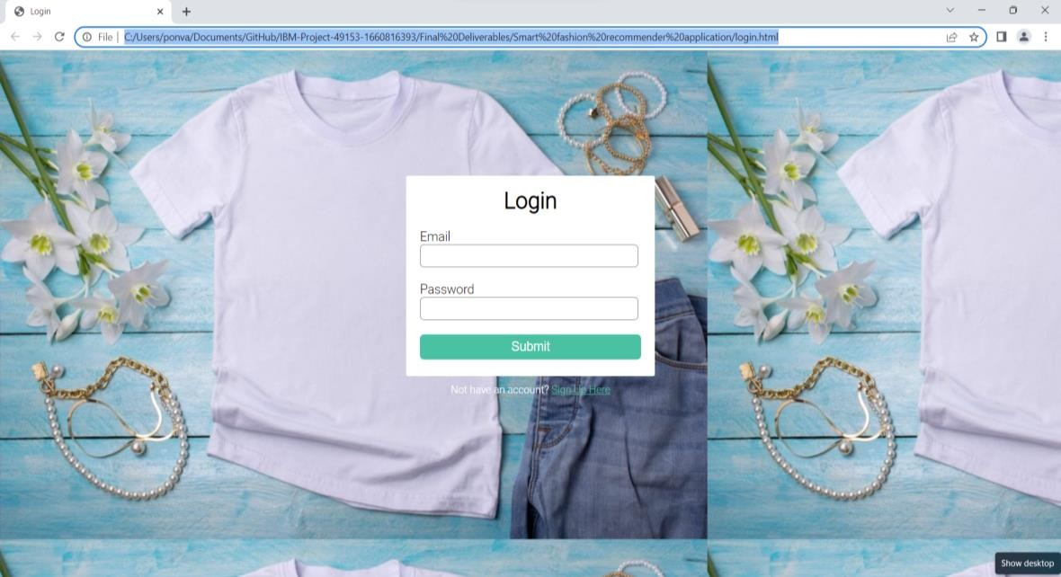

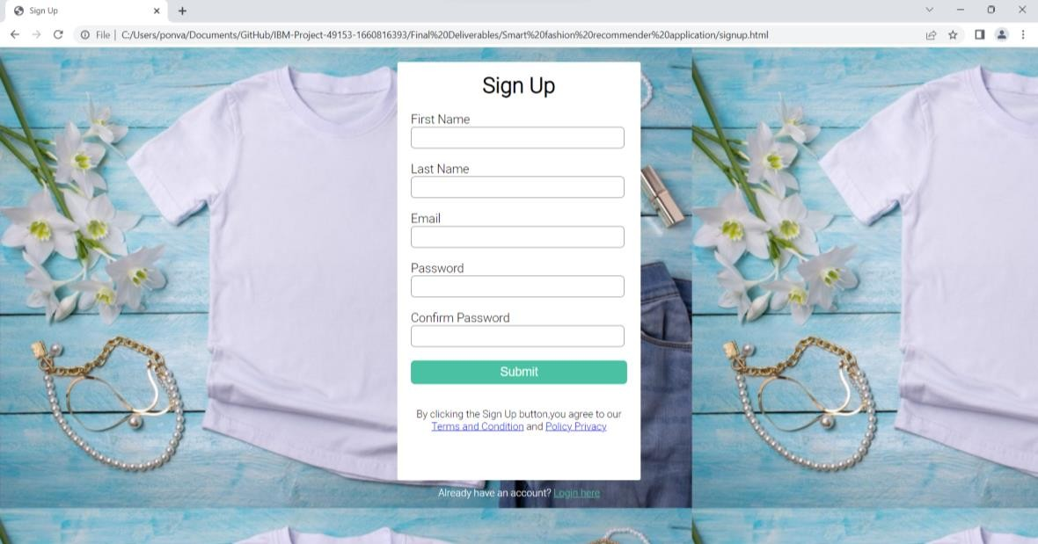

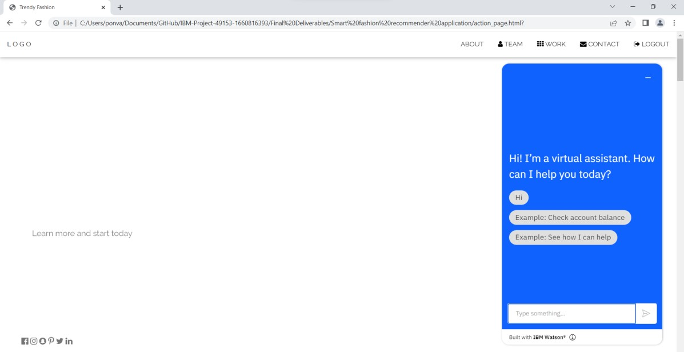

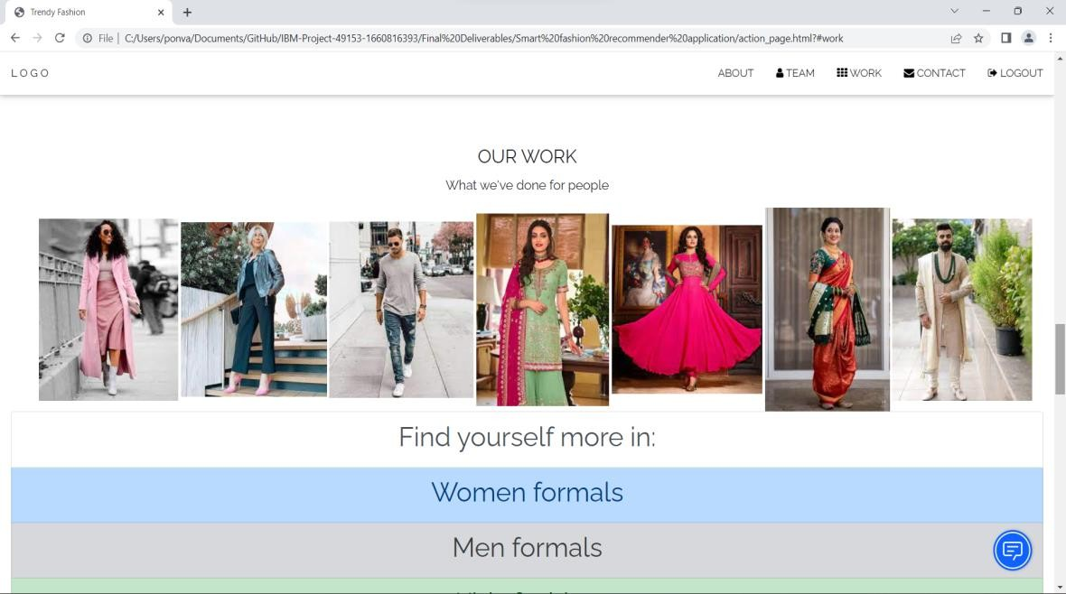

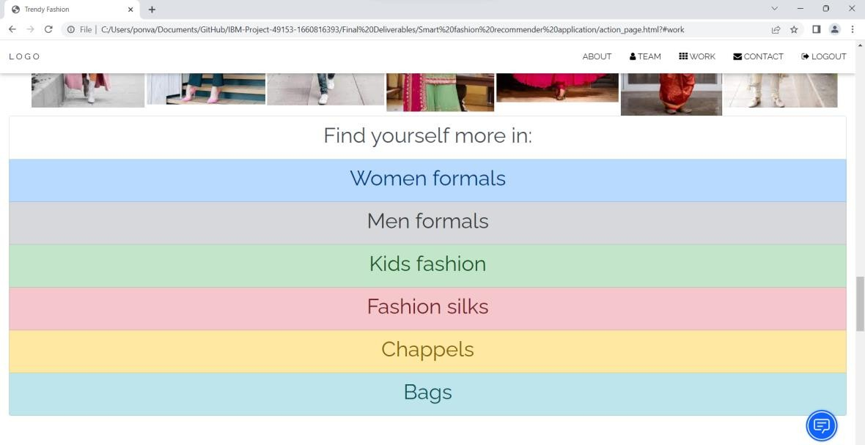

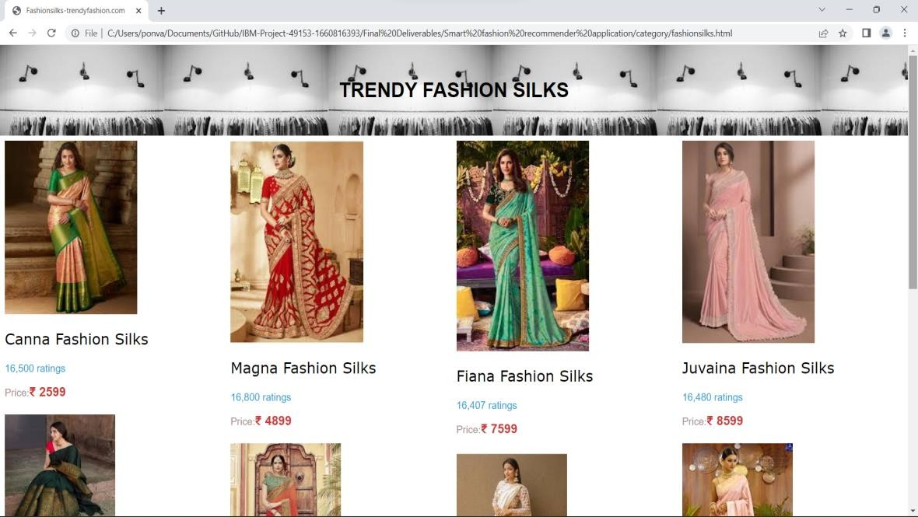

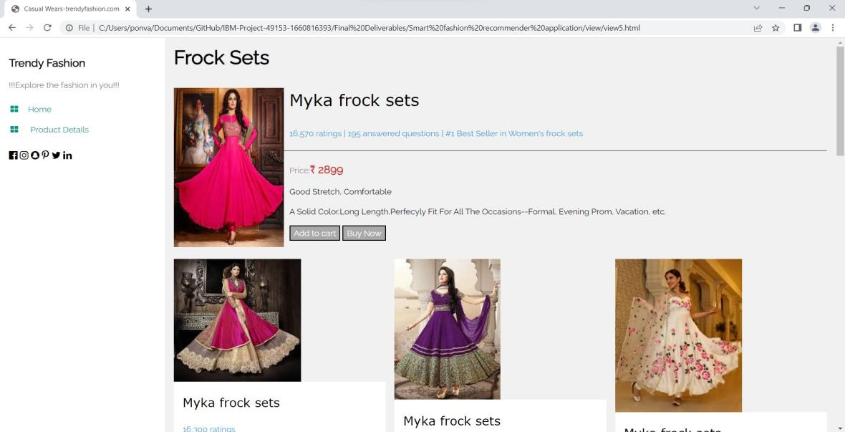

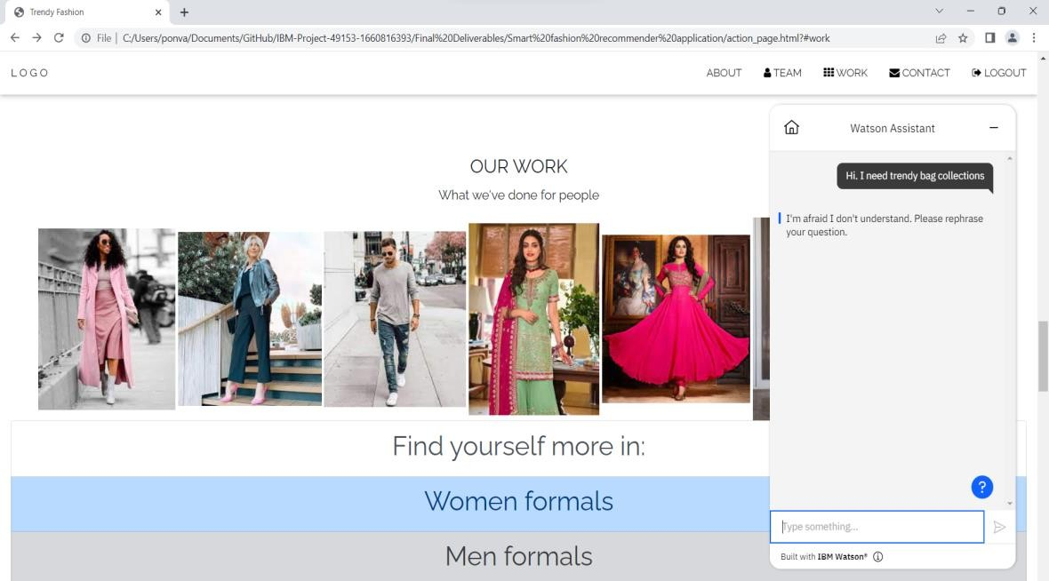

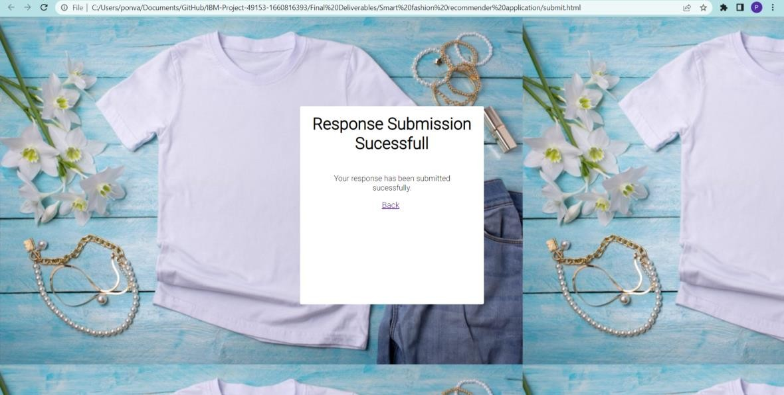

**CHAPTER 10 ADVANTAGES AND DISADVANTAGES**

# ADVANTAGES :

1. Low cost.
2. Simple UI.
3. Faster response due to single page web page.
4. Capability of adding many features with ease and less cost.

# DISADVANTAGES :

1. Lack of efficiency . Efficiency of the application needs to be improved.
2. Users are able to buy only a small part of the items of an e-commerce website and on the other hand articles have a limited stock, which can in turn hinder the task of recommender systems working with user-item fit feedback.
3. Lack of consistency between brands

# CHAPTER 11 CONCLUSION

Smart recommendation systems have the potential to explore new opportunities for retailers by enabling them to provide customized recommendations to consumers based on information retrieved from the Internet. They help consumers to instantly find the products and services that closely match with their choices. Moreover, different stat- of-the-art algorithms have been developed to recommend products based on users’ interactions with their social groups. This paper presented a review of the fashion recommendation systems, algorithmic models and filtering techniques based on the academic articles related to this topic. The technical aspects, strengths and weaknesses of the filtering techniques have been discussed elaborately, which will help future researchers gain an in- depth understanding of fashion recommender systems. This web application helps the customers to analyse and choose the products quickly without wasting much time . It also helps the customers to clarify their doubts by interacting with chatbot and provides customer satisfaction . Therefore , the project based on Smart fashion recommender system is implemented successfully.

# CHAPTER 12 FUTURE SCOPE

Even though harvested datasets are easy to collect and correspond well to real prediction tasks (e.g., purchase estimate), collected datasets are noisy; they may also not reflect the real semantics of visual preferences, compatibility, or other aspects of a user’s experience. For instance, a marketing image may try to promote a pair of shoes by pairing it with a “boring” (non-distracting) outfit; thus curated data may not be any more “real” than harvested data . In future , it rectifies all problems and modifies it to best fashion recommender application.

# CHAPTER 13 APPENDIX

**CLOUD APP DEVELOPMENT**

Cloud application development is the process through which a Cloud-based app is built. It involves different stages of software development, each of which prepares your app to go live and hit the market. The best Cloud app development teams use [DevOps practices](http://www.koombea.com/services/devops) and tools like [Kubernetes.](http://www.koombea.com/blog/devops-tools-kubernetes/)

However, an [experienced app development company](http://www.koombea.com/) should ideally be technology agnostic, which means being able to build your Cloud app using any technology you prefer. Most apps built using the Cloud are highly dependent on the Cloud to operate. Application development on Cloud infrastructure allows web and PWA development services to reduce development costs, opens up the possibility to work with remote teams, and reduces project times if used correctly with software development methodologies like Agile. However, not all companies are experienced enough to perform many complex aspects of the app development process using the Cloud. Businesses looking to develop digital products like web-based Cloud applications need to make sure that they work with a trusted Cloud-experienced app development company. Cloud-based application development solutions make data collecting more convenient for businesses. On top of that, security and management are simplified to a greater extent. Cloud app development allows modern businesses and enterprises to create productivity-based applications to enhance the customer experience as well as revenue. Not only this, but Cloud software development solutions also allow businesses to invest in low-code app development, which is again a time- and cost- effective process. Cloud App supports two protocols for device connection and communication MQTT and HTTP.

# MQTT

MQTT is a standard publish/subscribe protocol that is frequently used and supported by embedded devices, and is also common in machine-to-machine interactions.

# HTTP

HTTP is a "connectionless" protocol with the HTTP bridge, devices do not maintain a connection

to Cloud IoT Core. Instead, they send requests and receive responses.

# CLOUD DEVELOPMENT TOOLS :

**KUBERNETES**

Kubernetes or k8 is a cloud orchestration platform that allows cloud developers to deploy, maintain, and scale containerized applications. Developers can join together the host running container apps and Kubernetes helps to manage these clusters by automating most of the manual tasks involved. The tool can be used on a private cloud, public cloud, or a hybrid cloud setup and is, therefore, suitable for efficiently building and managing cloud-native applications requiring real-time data streaming, etc. The main advantage of Kubernetes for cloud developers is that it enables container-based application development. It automates operational tasks and lets you control updates and deployments, scale cloud resources while an application is deployed and running, manage services, orchestrate an app across multiple hosts, etc.

**MICROSOFT AZURE**

It is a cloud computing platform with a range of services from computing resources, networking, storage, analytics, etc. Cloud developers can select and use these services to develop, manage, and scale new or existing applications in the cloud. Microsoft Azure follows a pay-as-you-go model where users are charged an amount for the monthly use of selected cloud resources. Azure supports several open- source technologies and third-party tools that allow businesses to reach their organizational goals with flexibility.

# CLOUDANT

A fully managed, distributed database optimized for heavy workloads and fast- growing web and mobile apps, IBM Cloudant is available as an IBM Cloud® service with a 99.99% SLA. Cloudant elastically scales throughput and storage, and its API and replication protocols are compatible with Apache CouchDB for hybrid or multicloud architecture.

**SOURCE CODE LINK :** https://github.com/IBM-EPBL/IBM-Project-15944-1659606197